Vector Database Exploration Resources-

##### Vector DB Comparison

<https://superlinked.com/vector-db-comparison>

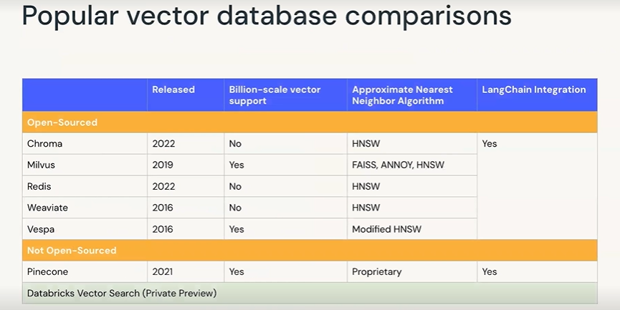

##### Vector Search and RAG General Overview and Databricks

<https://www.databricks.com/blog/introducing-databricks-vector-search-public-preview>

<https://www.databricks.com/product/machine-learning/vector-search>

[https://www.databricks.com/glossary/retrieval-augmented-generation-rag#:~](https://www.databricks.com/glossary/retrieval-augmented-generation-rag" \l ":~:text=Retrieval%20augmented%20generation%20or%20RAG%20is%20an%20architectural%20approach%20that,as%20context%20for%20the%20LLM" \t "_new)

[=Retrieval%20augmented%20generation%20or%20RAG%20is%20an%20architectural%20approach%20that,as%20context%20for%20the%20LLM](https://www.databricks.com/glossary/retrieval-augmented-generation-rag" \l ":~:text=Retrieval%20augmented%20generation%20or%20RAG%20is%20an%20architectural%20approach%20that,as%20context%20for%20the%20LLM" \t "_new)

##### Full Stack Gen AI App on Databricks

<https://www.databricks.com/resources/demos/tutorials/data-science-and-ai/lakehouse-ai-deploy-your-llm-chatbot>

[https://notebooks.databricks.com/demos/llm-rag-chatbot/index.html#](https://notebooks.databricks.com/demos/llm-rag-chatbot/index.html)

##### Databricks Vector Search Specific Documentation

<https://learn.microsoft.com/en-us/azure/databricks/generative-ai/vector-search>

<https://docs.databricks.com/en/generative-ai/create-query-vector-search.html>

<https://learn.microsoft.com/en-us/azure/databricks/generative-ai/create-query-vector-search>

<https://pypi.org/project/databricks-vectorsearch/>

##### Databricks Vector Search Costs

<https://www.databricks.com/product/pricing/vector-search>

<https://www.databricks.com/product/pricing/product-pricing/instance-types>